Alien banjo attackers from space user manual

The aim of this game is to fend off the hordes of alien banjos that are attacking earth, using your trusty accordion you venture to space as the last hope of earth. This game has a simple concept as the mobs gradually move down the screen towards the player and the player has to shoot them with notes before they reach you or the bottom of the screen.

# Install and setup

All you need to set up and play the game is to copy the “executable” folder to wherever you want it and double click the “Space Banjo.exe” to run the game.

# Menu

When you first start the game you will be prompted by a menu.

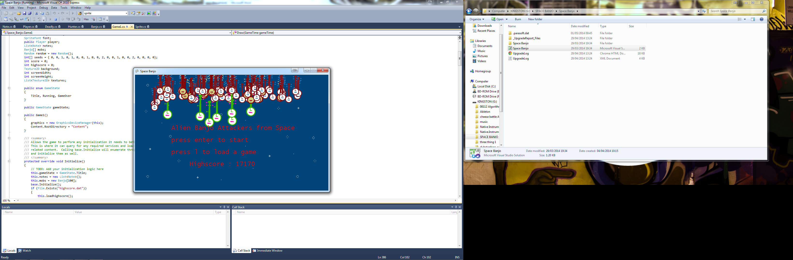

From this menu you can start a new game by pressing enter, if there is an existing save from a previous game this will be automatically loaded when the game starts.

# Game

When you press enter a new game will start and you will see this screen.

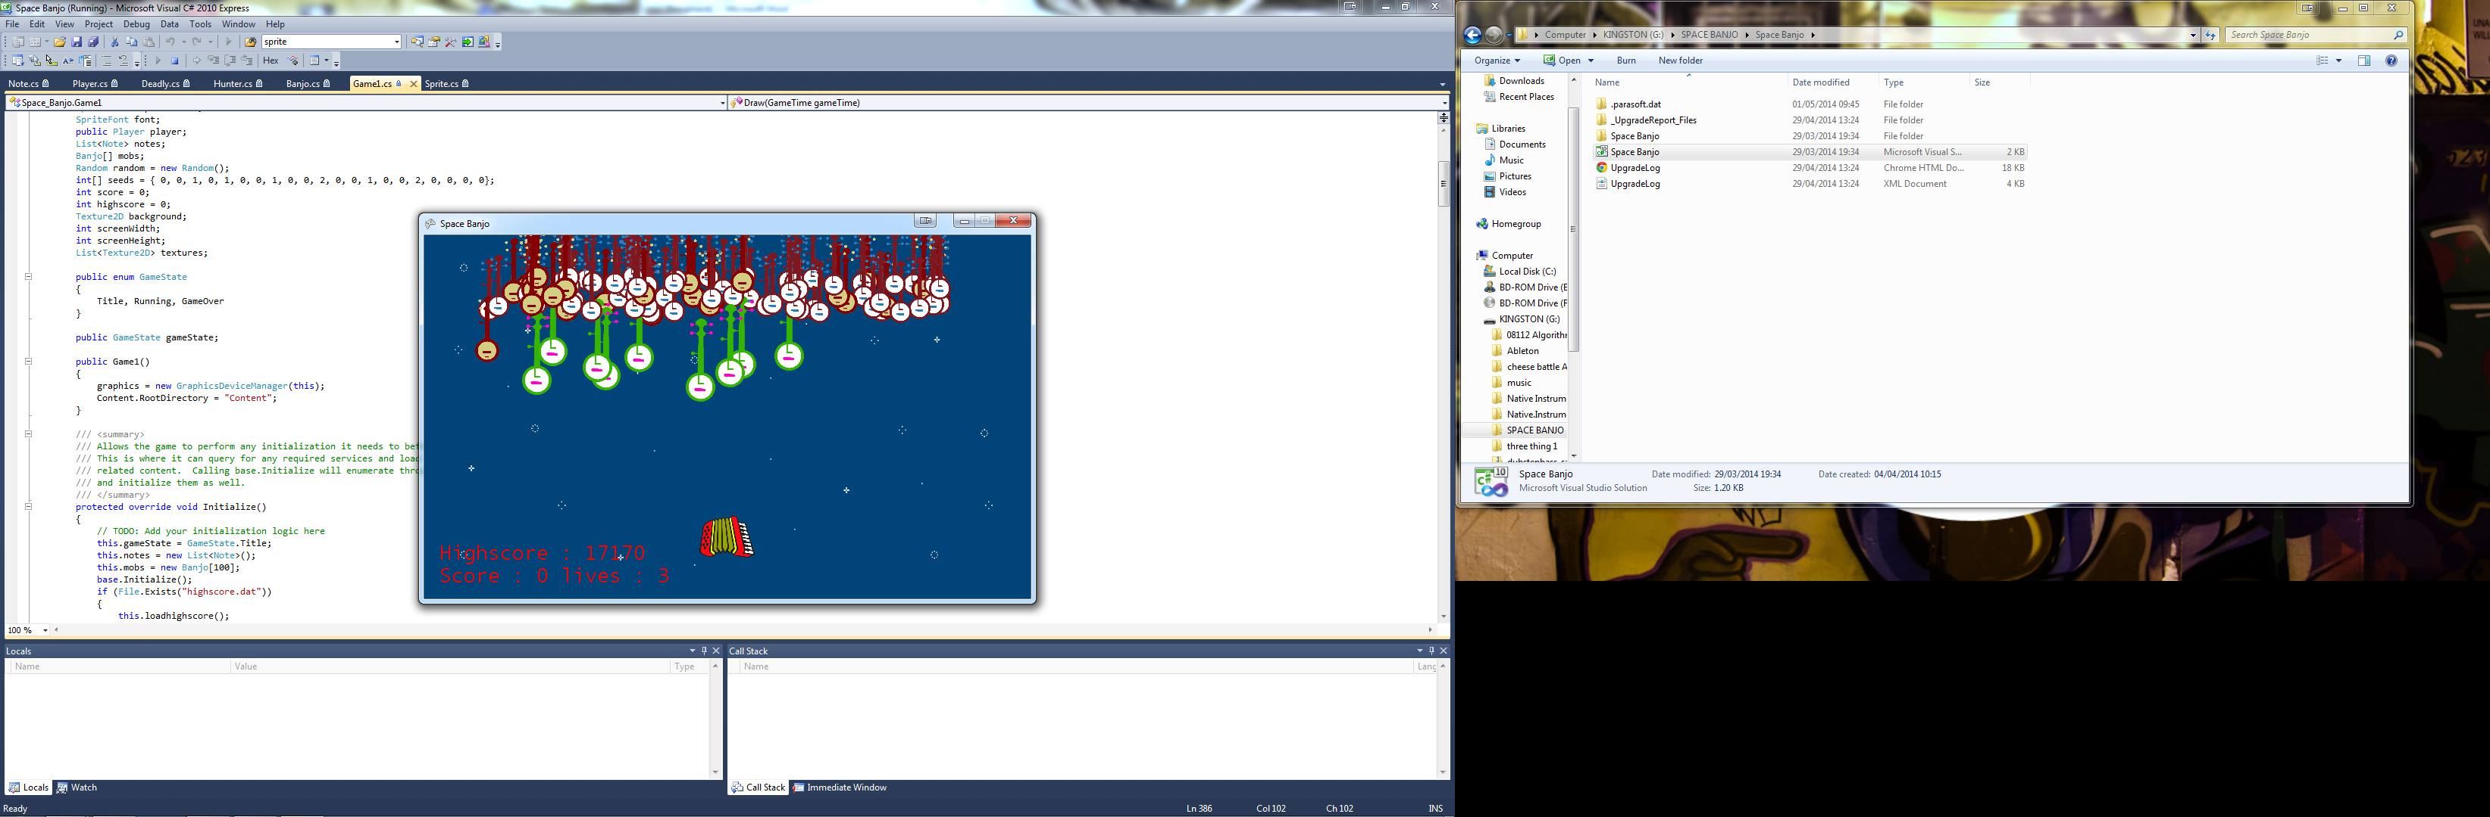

This is the main game screen and from here you play the game. You are the accordion at the bottom of the screen, to move you use the left and right arrow keys and to shoot notes at the enemy banjos you press space. At any point while playing the game you can press the S button to save the game this means that if you quit when still playing when you run the game again the previous save will automatically load, however when you die the saved game gets deleted meaning you have to start again.

# Enemies

There are 3 types of banjo attacking earth:

* Normal banjos

These banjos are the grunts of the attacking force spawning much more frequently than other banjos. These banjos only have one health and they move from side to side moving down whenever they hit the side of the screen. These banjos are only worth 10 points when killed.

* Hunter banjos

These banjos are the soldiers of the attacking force and spawn less frequently than the previous type. They act like normal banjos for 5 seconds then they change tactics and charge at the player until killed. These banjos also only have one health and are worth 20 points when killed.

* Deadly strummers

These banjos are the elites of the attacking force and spawn even less frequently than before. They chase the player as soon as they appear and move extra quickly, they also take 2 hits to kill and are worth 50 points when killed.

# Game over

In the game you have 3 lives, you can lose a life by being hit by an enemy banjo or if an enemy banjo gets past you and escapes down to earth. When you lose all your lives you will be shown the game over screen, to go back to the menu from here you press the esc button.

